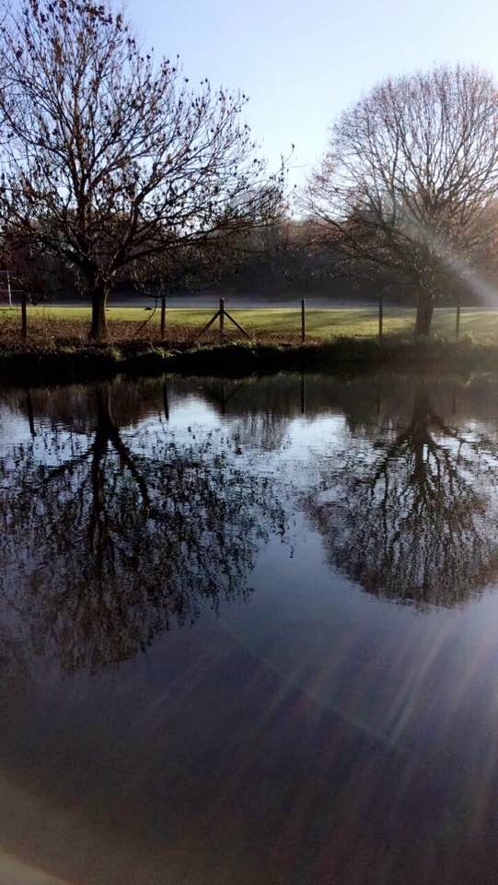
We are launching the first ever official survey of otters and shrews in Birmingham canals, and we need your help!
What’s Involved? | We need volunteers to survey stretches of canal in their local area. Sites will need to be surveyed once a week for a period of two months. It will take approximately 1.5 hours to survey the site each time. Surveying is easy, we will train you in how to spot otter signs and lay shrew traps, and all you need to do is fill in a survey sheet each time you go out.
What’s in it for me? | - Actively aid in conserving these great species!  - Learn new skills.  - Meet new people.  - Get updates on how the survey is going.  - Have the chance to enjoy walking along the great canals of Birmingham and seeing what they have to offer.
How do I find out more? | Sign up to one of our introduction/training events (Details to be confirmed). Or contact either:  Samantha Mason: ssm385@student.bham.ac.uk (Survey coordinator).  Paul Wilkinson: Paul.Wilkinson@canalrivertrust.org.uk (Canal and Rivers Trust Ecologist).
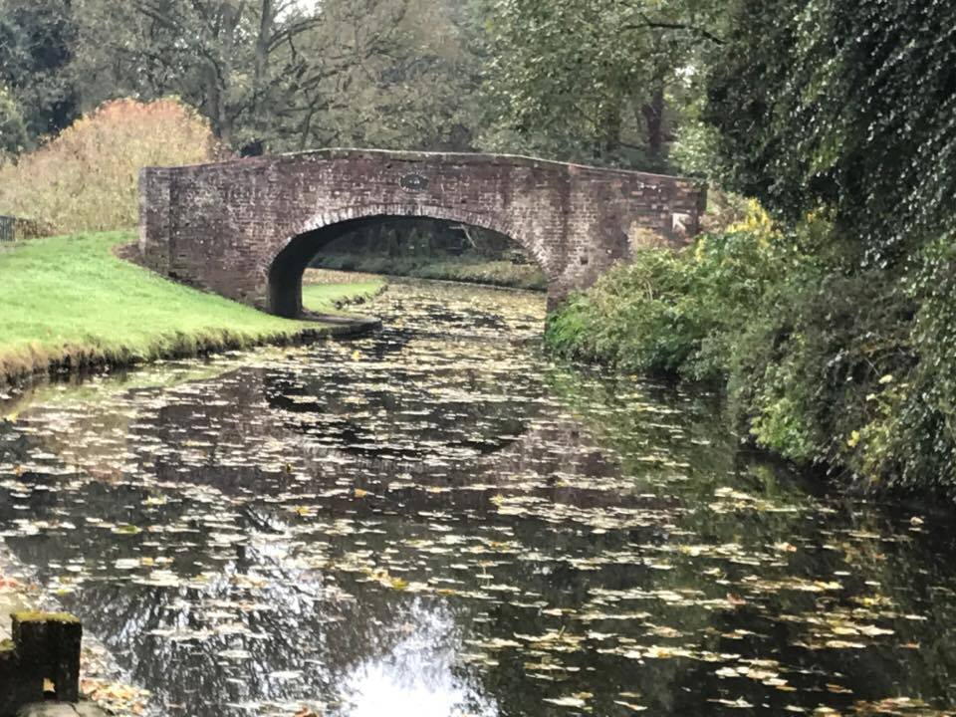
Shrews are fascinating little creatures, did you know that Water shrews have venomous saliva? Despite this (and their cuteness) we know very little about them, and where they are. We’ve found evidence of the Water shrew as well as the Common and Pygmy shrew along many of the Birmingham canals, and we therefore want to find out more about where these guys are hiding!
Otters are showing signs of recovery after their dramatic decline in the 1950s, and have now been spotted in rivers, lakes and coastal areas throughout Britain. However, what people might not realise is that canals can offer a safe haven for otters too! In Birmingham otters have been sighted in many of the canals, right into the city centre. Until now though there has not been an official survey, which is where you come in!

